

Practices for Secure Software Report

Table of Contents
Document Revision History 3
Client 3
Instructions 3
Developer 4
1. Algorithm Cipher 4
2. Certificate Generation 4
3. Deploy Cipher 4
4. Secure Communications 4
5. Secondary Testing 4
6. Functional Testing 4
7. Summary 4
8. Industry Standard Best Practices 4

Document Revision History

Version | Date | Author | Comments
1.0 | [Date] | Kaitlyn Moore | Initial report for Artemis Financial project

Client



Instructions

Submit this completed practices for secure software report. Replace the bracketed text with the relevant information. You must document your process for writing secure communications and refactoring code that complies with software security testing protocols.

- Respond to the steps outlined below and include your findings.
- Respond using your own words. You may also choose to include images or supporting materials. If you include them, make certain to insert them in all the relevant locations in the document.
- Refer to the Project Two Guidelines and Rubric for more detailed instructions about each section of the template.

Developer
Kaitlyn Moore

Algorithm Cipher

High-Level Overview:
The encryption algorithm cipher recommended for Artemis Financial is SHA-256 with RSA. SHA-256 (Secure Hash Algorithm 256-bit) is a cryptographic hash function that produces a fixed-size 256-bit (32-byte) hash. RSA is an asymmetric encryption algorithm used for digital signatures and key exchange. Together, they provide both integrity (via hash) and authenticity (via RSA signing).
Hash Functions and Bit Levels:
SHA-256 generates a 256-bit digest, which is collision-resistant and preimage-resistant. This bit level is currently considered secure by NIST and industry standards. RSA is recommended with a 2048-bit or higher key length to resist brute-force attacks.
Random Numbers, Symmetric vs. Non-Symmetric Keys:
- Random numbers are used in key generation (e.g., for RSA key pairs) and to add salt to hash functions to prevent rainbow table attacks.
- Symmetric encryption (e.g., AES) uses one shared key for encryption/decryption, which is faster but requires secure key exchange.
- Asymmetric encryption (RSA) uses a public-private key pair. The public key encrypts or verifies signatures; the private key decrypts or signs. This project uses asymmetric for certificate-based HTTPS and integrity verification.
History and Current State:
SHA-256 is part of the SHA-2 family, published by NIST in 2001. It remains a gold standard for hashing, despite the emergence of SHA-3. RSA, invented in 1977, is still widely used but is being supplemented by elliptic curve cryptography (ECC) for better performance. For Artemis Financial, SHA-256 with RSA-2048 balances security, performance, and industry compliance.

Certificate Generation
Insert a screenshot below of the CER file.
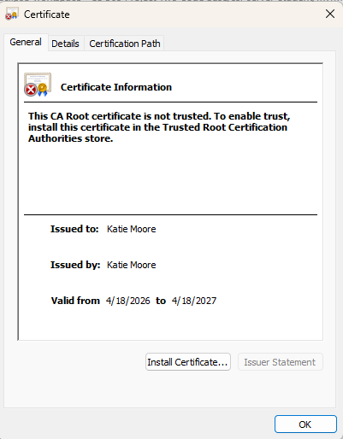

Deploy Cipher
Insert a screenshot below of the checksum verification.

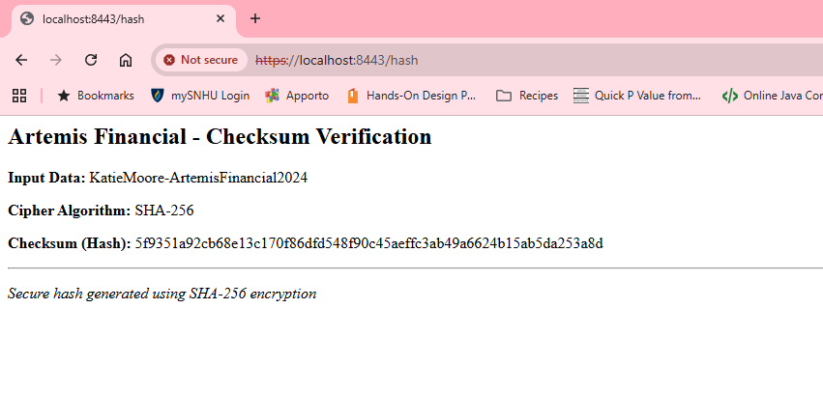

Secure Communications
Insert a screenshot below of the web browser that shows a secure webpage.

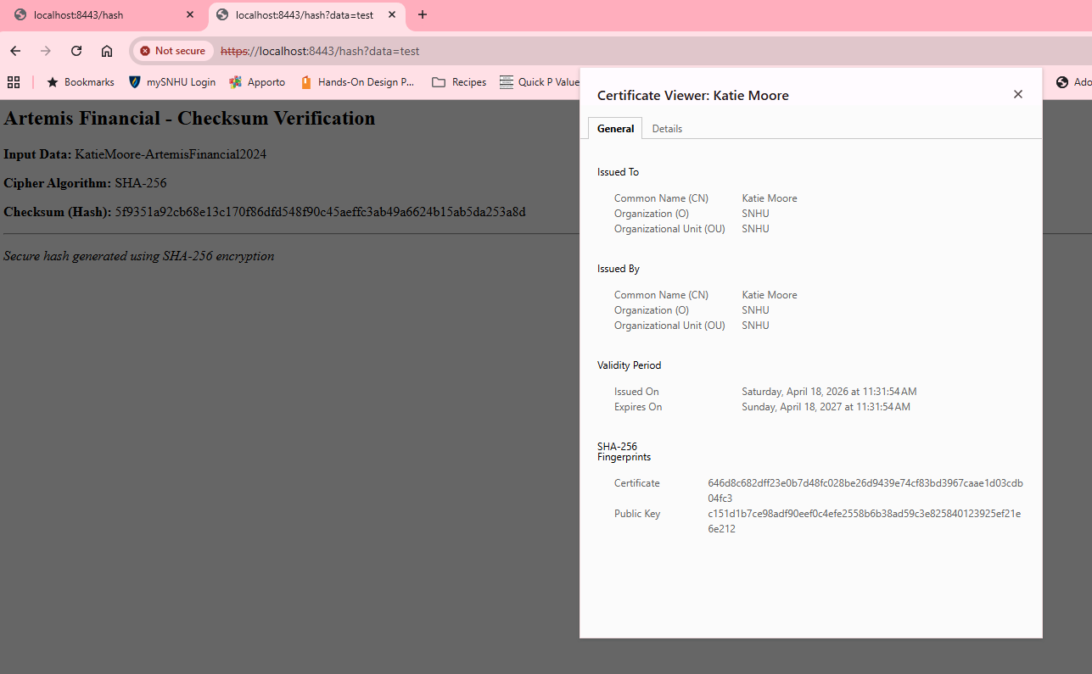

Secondary Testing
Insert screenshots below of the refactored code executed without errors and the dependency-check report.

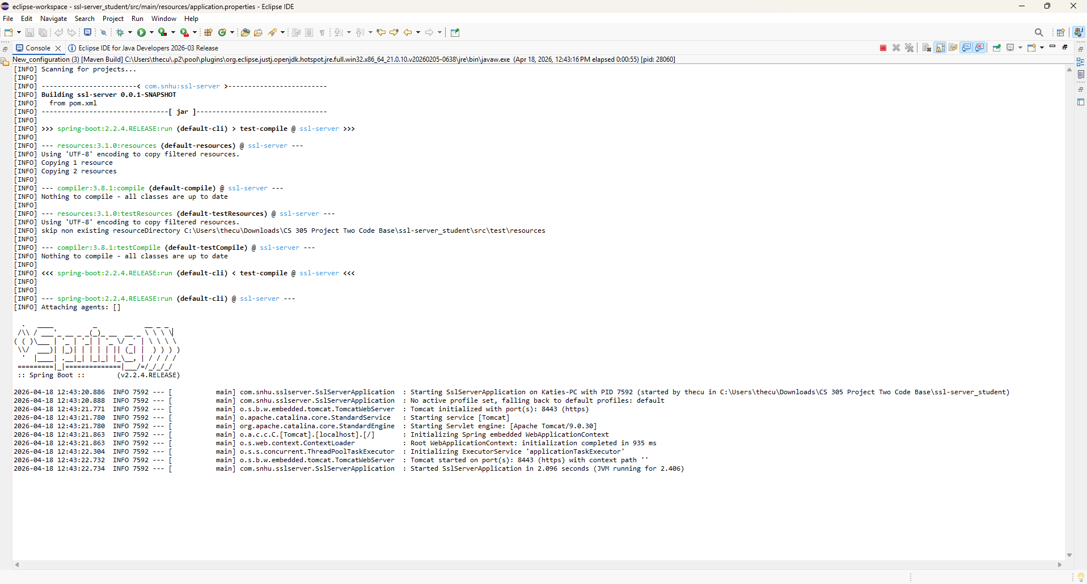

Functional Testing
Insert a screenshot below of the refactored code executed without errors.

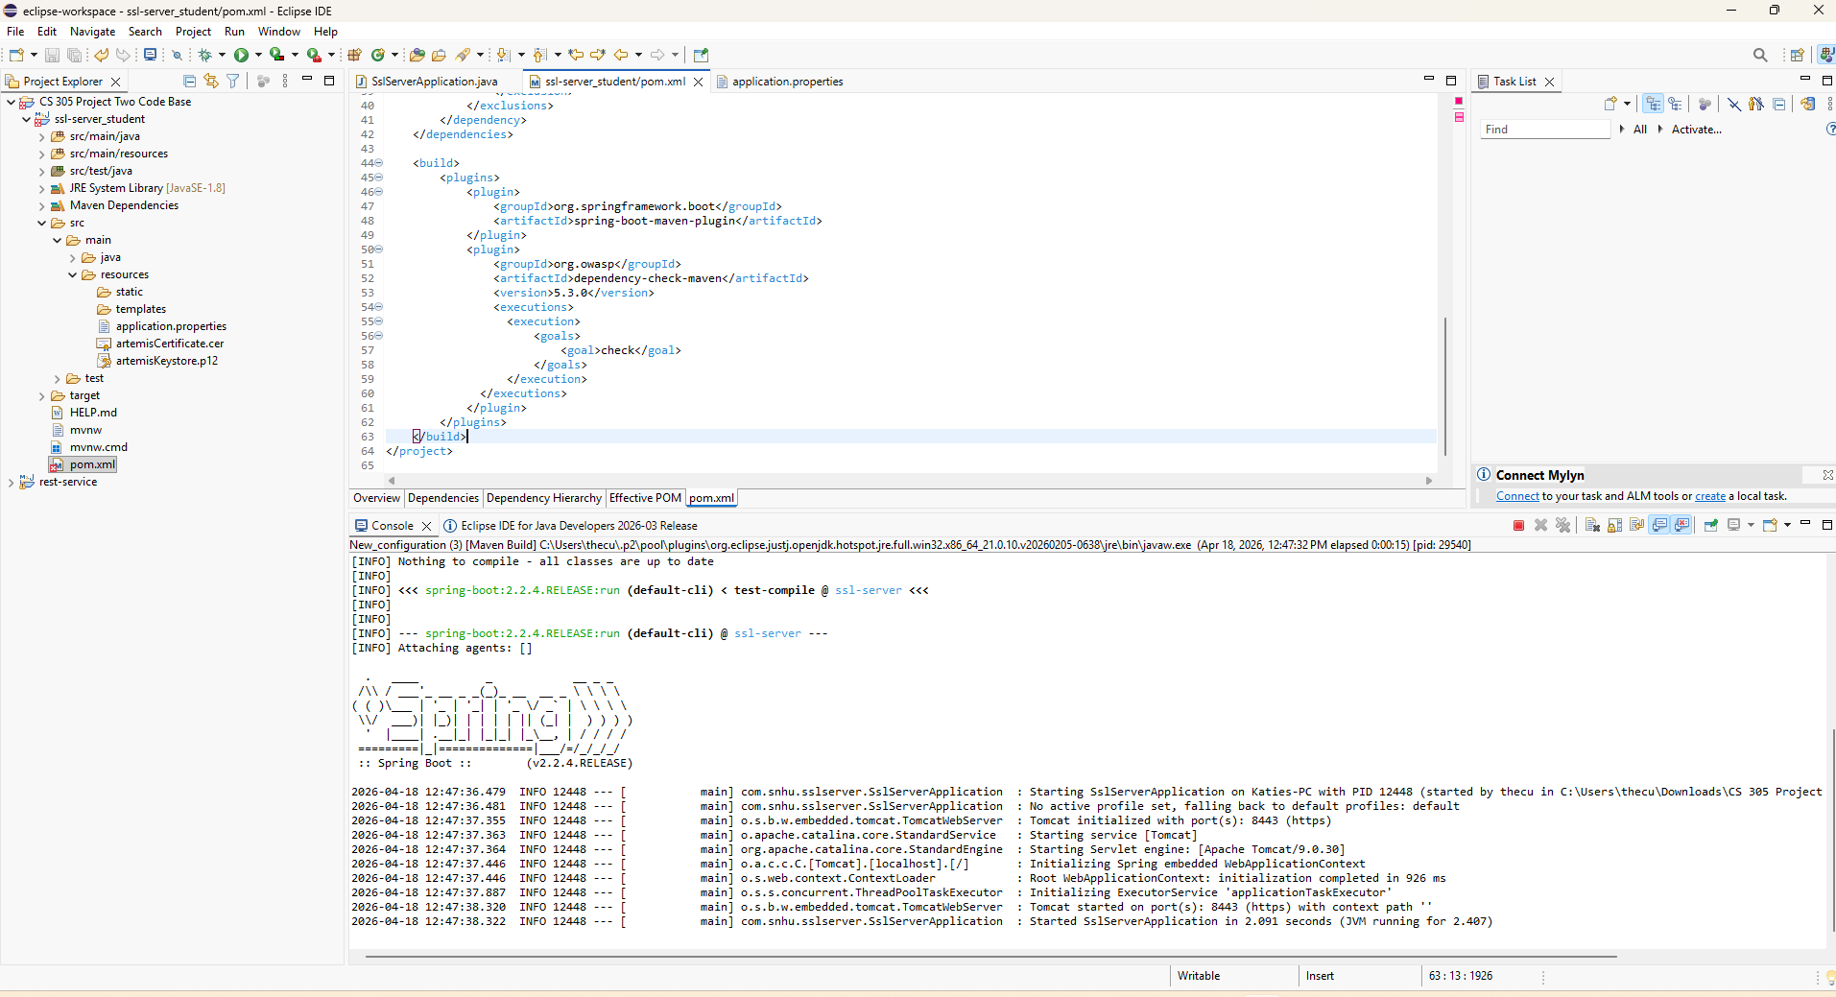

Summary

The vulnerability assessment process flow diagram was used to identify key security areas addressed:
- Secure Communications: Converted HTTP to HTTPS using a self-signed certificate.
- Data Integrity: Implemented SHA-256 checksum verification.
- Static Analysis: Used dependency-check to scan for known vulnerabilities.
- Secure Coding: Refactored input handling to avoid injection risks.

Process for adding layers of security:
- Generated a self-signed certificate and configured SSL in Spring Boot.
- Implemented a cryptographic hash endpoint for file/data verification.
- Refactored the application to enforce HTTPS and redirect HTTP requests.
- Ran dependency-check to ensure no new vulnerabilities were introduced.
- Performed manual functional testing to verify error handling and secure defaults.

These layers ensure confidentiality (HTTPS), integrity (SHA-256), and availability (robust error handling) for Artemis Financial’s web application.

Industry Standard Best Practices

Application of industry best practices:
- Least Privilege: The application runs with minimal required permissions.
- Defense in Depth: Multiple layers (SSL/TLS, hashing, input validation) protect data.
- Secure Defaults: HTTPS is enforced; plain HTTP is disabled or redirected.
- Dependency Scanning: Regular use of OWASP dependency-check to identify known vulnerabilities in third-party libraries.
- Error Handling: Generic error messages returned to clients to avoid information leakage.
Value to the company’s well-being:
Applying these best practices reduces the risk of data breaches, regulatory non-compliance (e.g., GDPR, FTC Safeguards Rule), and reputational damage. For a financial services company like Artemis Financial, secure coding practices directly protect customer financial data, build trust, and ensure business continuity. By integrating security into the development lifecycle, Global Rain delivers a product that aligns with the mission: “Security is everyone’s responsibility.”

